PRI Assessment Methodology – Overview
This is an overview of the assessment methodology for the PRI Reporting Framework.
It outlines how indicators will be aggregated to produce an overall module score and performance band for each signatory. For detailed per-indicator assessment methodology, please see the Reporting Framework documents.
A mock Assessment Report showing how signatories’ scores are presented can be found here.
Signatories will have their Assessment Reports made available to them in early July each year, based on responses they submitted during the recent reporting period. PRI will not publish the Assessment Reports, but signatories may wish to publish or share this report. Should they choose to share/publish, they must:
- Include a link to the PRI assessment methodology
- Include access to a copy of the full Assessment Report, if only a section is published in summary
- Include access to their public Transparency Report
- Take every care not to represent scores out of context

Please note that prior to publishing Assessment Reports the PRI may need to revise the methodology for individual indicators. As such the following document should be viewed as a guideline only and may not reflect the final version.

Table of Contents

Assessment Aims 2
Assessment Design Principles 2
Assessment Methodology 2
Overview 2
Indicator Scoring 2
Indicator Scorecard 2
Module Scoring 2
Assessing and Discarding Additional Indicators 2
Exceptions to simple aggregation in module scores 2
Summary Scorecard 2
Module Peer Comparison 2
The Data Portal 2

Assessment Aims
The Assessment methodology and Assessment Report together aim to achieve three objectives set by the PRI Board, the Reporting and Assessment Advisory Committee (RAAC) and the signatories that participated in earlier consultations on the new Framework:
- Facilitate learning and development by outlining how the implementation of responsible investment within signatories compares year-on-year, across asset classes, and with peers at the local and global level;
- Identify areas for further improvement; and
- Strengthen the dialogue between asset owners and investment managers on responsible investment activities and capabilities.
The PRI recognises that there are many valid approaches to responsible investment and signatories are at different stages of implementing the Principles. Some are just starting to develop their policies while others already have detailed policies, processes and resources in place. The intention of the Assessment methodology is to reflect different stages of implementation in broad terms using six standardised performance bands, rather than to make judgements about small differences between signatories at similar levels of implementation.

Assessment Design Principles
During several consultations on the Assessment methodology in 2013 onwards, the RAAC and signatories made it clear that the design of the scoring system should be as easy to understand as possible. With this goal in mind, the methodology has been designed as follows:
- Each of the assessed modules will have a consistent scoring approach;
- Equal weighting will be applied to individual indicators (where indicators include information about different practices, the practices will be assessed separately but will be weighted equally);
- Only closed-ended indicators are assessed. Since 2015, six standardised performance Bands (A+, A, B, C D and E) are used to communicate signatories’ performance at the module level. The band A+ and band E were introduced that year to distinguish and provide signatories with more granular feedback.
- A signatory who has an asset class that represents less than 10% of its AUM (for which a dedicated module exists in the Reporting Framework) but chooses not to report on it will have the asset class marked “Not reported” in the Summary Scorecard.

Assessment Methodology

Overview
Each module will contain two types of assessed indicators:
- Core assessed: all signatories will be assessed on these indicators and they will make up the majority (~75%) of their overall assessment score for each module. These indicators will frequently, but not always, be mandatory to disclose. Completing these indicators and demonstrating advanced levels of implementation will enable a signatory to reach the third-highest performance Band (B); and
- Additional assessed: signatories can generally complete these indicators if they wish (i.e. they will usually be ‘voluntary to report’) and they will provide an opportunity to demonstrate more advanced stages of implementation or reflect alternative practices. Scores from these indicators can only add to the final score for each module, and when combined with their scores on Core assessed indicators, have the potential to push signatories into a higher performance band (see ‘Assessing and Discarding Additional Indicators’ below). To achieve the highest possible Bands (A and A+), a signatory will need to complete and score well on some, but not all, of these indicators.
Further indicators will capture information to enable comparison of signatory responses (known as ‘peering indicators’) while others will help determine whether a signatory needs to complete further indicators or sub-indicators in later stages of the framework (known as ‘gateway indicators’). Although these indicators will not be assessed, they may impact which assessed indicators signatories complete and the types of organisations they will be peered against. Both types of indicator will always be mandatory to report but will only be mandatory to disclose where appropriate.

Indicator Scoring
Signatories will receive a score for each ‘Core assessed’ and ‘Additional assessed’ indicator in every relevant module. The score falls into four categories, ranging from (no stars) to (three stars). For binary indicators with only ‘Yes’/’No’ response options, these will be the only two scores available (respectively 3 stars/0 star).
An indicator can also be scored as “not applicable” in the Indicator Scorecard because the indicator is not relevant to the signatory based on its reporting answers. In such case, the indicator will not be taken into account in calculating the module performance band.

Indicator Scorecard
An indicator scorecard will summarise the scores achieved for all ‘Core’ and ‘Additional assessed’ indicators completed within a module on an absolute basis. It will also provide basic information about the relative performance of the organisation compared to that of other signatories for which that indicator is relevant. When less than eight signatories respond to an indicator, the median peer score will not be displayed to protect confidentiality. A sample scorecard (Strategy & Governance module) is presented below.

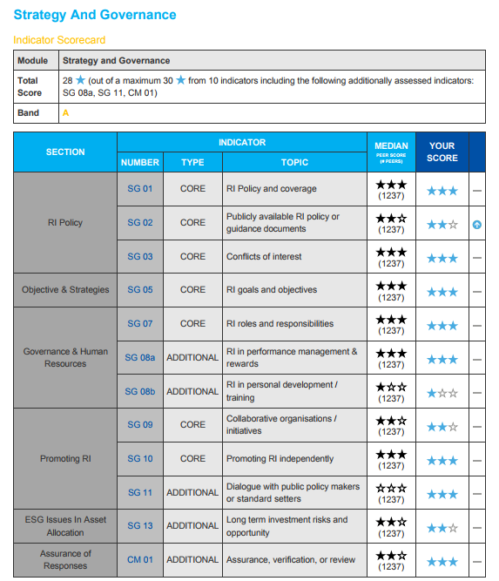

Explanatory Notes

Section Where the indicator appears within the module
Number Indicator number
Type Whether the indicator assessment type is “Core” or “Additional”
Topic A short overview of what the indicator covers
Median Peer Score The signatory’s positioning relative to all other organisations for which that indicator was relevant (number in brackets denotes the number of organisations that responded to that indicator)
Your Score Signatory’s indicator score (on a scale of zero to three stars)
YoY Signatory’s year-on-year performance for that indicator (not available until a signatory has completed two complete reporting cycles)

Module Scoring
Each signatory’s module score will fall in six broad ranges to be assigned based on their score in a specific module (presented below). Only the final performance band – and not the percentage – will be included in the assessment report.
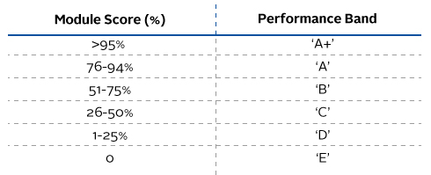
All ‘Core assessed’ indicators will count towards a signatory’s module score, up to a maximum of 75% of the overall module score. This means a signatory can achieve the third-highest performance Band (B) by reporting on all of the ‘core assessed’ indicators and scoring well on them. ‘Additional assessed’ indicators typically cover alternative or advanced practices and by reporting, and scoring, on only a selection of these ‘Additional assessed’ indicators, signatories can improve their score and potentially advance to the highest performance Bands (A and A+).

Assessing and Discarding Additional Indicators
The maximum score (100%) for each module will be based on the maximum score of all ‘Core’ assessed’ indicators and the maximum score of a subset of the ‘additional’ assessed indicators. The signatory will then receive a score based on the ‘Core’ indicators and on the highest scoring ‘additional’ indicators.
These highest scoring ‘Additional’ indicators will be mentioned in the Indicator Scorecard of all assessed modules.
For example, if a module has twelve indicators (see example below), of which seven are ‘Core’ and five are ‘Additional’, the maximum assessment will be based on all seven ‘Core’ indicators [7 × 3 = 21 = 70%] and the three highest scoring ‘Additional’ indicators to make up the remaining 30% of the module score [3 × 3 = 9= 30%]. This results in the two lowest scoring ‘Additional’ indicators being discarded and the denominator being ten indicators [21 + 9 = 30= 100%] rather than all twelve indicators.
Indicator type | Indicator no. | Your Score | Scored | Explanation
Core | 01 |  |  | Core indicators are always scored
Core | 02
Core | 03
Core | 04
Core | 05
Core | 06
Core | 07
Additional | 08 |  | X | The lowest scoring ‘additional assessed’ indicators will not count towards the total score
Additional | 09 |  | X
Additional | 10 |  |  | Highest scoring ‘additional assessed’ indicators will count towards the total score
Additional | 11
Additional | 12
MODULE TOTAL |  | 27 (Maximum 30)
MODULE SCORE |  | A |  | (based on the 90% achieved: 27/30)

The graph below presents how ‘Core’ and ‘Additional’ assessed indicators are combined for your Module Score based on the number of indicators in the example above.
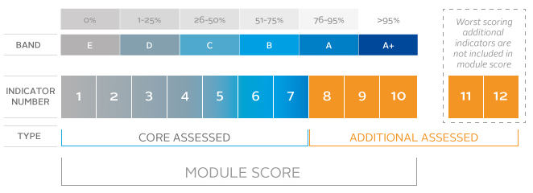
‘Additional’ indicators’ do not just raise signatories’ scores to Bands A and A+. Stars scored in Additional indicators will always improve a signatory’s score, even if the signatory has low scores for the ‘Core’ indicators in that module.

Exceptions to simple aggregation in module scores
Generally, module scores will be calculated simply by aggregating the scores for all mandatory ‘Core indicators’ and the voluntary ‘Additional indicators’ that have not been discarded in a module. The only exceptions to this will be:
- Selection, Appointment and Monitoring of external managers (SAM) – each eight indirect asset classes (e.g. Listed Equity, Private Equity, etc.) will be scored and presented separately in the summary scorecard (See ‘Summary Scorecard below);
- Fixed Income (FI) – each four categories of fixed income assets (SSA, Corporate Financial, Corporate non-Financial and Securitised) will also be scored and presented separately in the Summary Scorecard.
- Listed Equity Incorporation (LEI) – the two active incorporation strategies (integration and screening) will be presented separately in the Assessment Report and the overall LEI score will be based on the signatory’s ‘main’ strategy. The main strategy is calculated by looking at coverage of assets (please see the LEI module for more details). Signatories who are 100% thematic and 100% passive will not be assessed;
- Listed Equity Active Ownership (LEA) – the LEA module is comprised of the engagement and (proxy) voting sections. Both will count towards a signatory’s LEA score but will be presented separately in the summary scorecard.
  - Engagement Score – organisations may be engaging internally, via collaborations and/or via service providers. The LEA score is not dependent on how they conduct their engagements and the top score can be achieved regardless of who conducts the engagements. They will see each applicable score separately and their overall engagement score will be based on their primary form of engagement (calculated on the number of engagements – please see LEA module for more details).

Summary Scorecard
The Summary Scorecard will present an overview of the performance bands achieved for each module completed by a signatory. These will be specific to each signatory and allow them to see, at a glance, their performance across asset classes compared to the median results of their peers.
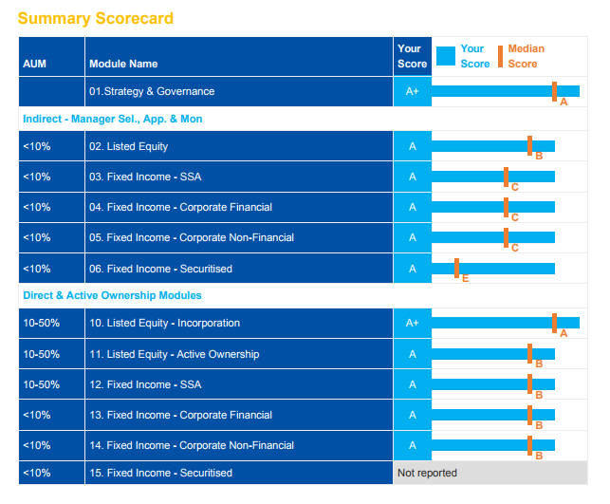

Module Peer Comparison
Two types of peering will take place at the end of each reporting period once submissions from all signatories have been received:
- Indicator level: Signatory scores for each indicator will be peered against all other signatories for whom that indicator was relevant, regardless of their type, size or location.
- Module level: Signatory scores for each module will be displayed in six broad performance Bands (E to A+) at an absolute level as well as relative to peers of a similar type, size or location.
Each signatory’s total aggregated module score will be compared to relevant peer groups in a series of distribution charts. Unlike 2014 and from 2015 onwards, investment managers will only be peered with other investment manager signatories while asset owners will continue to be peered with all signatories. This has been done to provide with more relevant and granular feedback and to improve learning outcomes for each type of signatory. Example of a peering chart below:
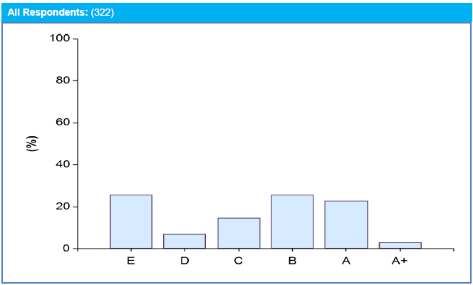

The Data Portal
A significant development in 2017 was the implementation of the Data Portal, an interactive online database designed for our signatories where they can:
- Access their own reports (Transparency and Assessment Reports) for the current reporting period and previous years;
- View other signatories public Transparency Reports;
- Request access to private information (Transparency and Assessment);
- Create bespoke peering data through the "My Peering" and "Peering Scores" functions.

For full instructions on how to register and use the Data Portal please see here.
The Data Portal is available here: https://dataportal.unpri.org
Guidance and links to further resources to support on-going learning and development are provided in the "PRI Reporting Framework Resources" document available on the Data Portal (see ‘Explore Data’ section, ‘Documents’).

